Chapter D - Ecology
Chapter 3 – Human Impact on Ecology
- 3.1 Human population growth presents challenges
  - As the population continues to grow, there is a greater demand for natural resources. Cities and countries share many resources. Increasing populations put pressure on ecosystems.
    - 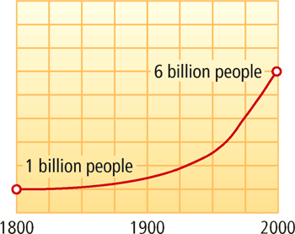
  - Natural Resources –
    - Any type of matter or energy from Earth’s environment that humans use to meet their needs.
  - Population Resources –
    - A measure of the number of organisms that live in a given area; the population density of a city may be given as the number of people living in a square kilometer.
- 3.2 – Human activities affect the environment
  - Pollutions –
    - Pollution and habitat loss make it difficult for plants and animals to survive. Without the necessary resources, biodiversity of living things decreases, and ecosystems become less stable.
  - Habitat Loss –
    - Pollution and habitat loss make it difficult for plants and animals to survive. Without the necessary resources, biodiversity of living things decreases, and ecosystems become less stable.
  - Population –
    - The release of harmful substances into the air, water, or land.
  - Biodiversity –
    - The number and variety of living things found on Earth or within an ecosystem.
- 3.3 – Humans are working to protect ecosystems
  - Working at local and governmental levels, humans are helping ecosystems recover. Laws protect endangered species.
  - Working at local and governmental levels, humans are helping ecosystems recover.
  - Conservation –
    - The process of saving or protecting a natural resource.
  - Sustainable –
    - A term that describes the managing of certain natural resources so that they are not harmed or used up; examples include maintaining clean groundwater and protecting topsoil from erosion.

