Chapter D - Ecology
Chapter 2 Interactions with Ecosystems
- 2.1 Groups of living things interact within ecosystems,
  - Members of the same spices form a population with in a habitat.
  - Each species has a distinct role with in a habitat. This is its niche.
  - Species -
    - A group of living things that are so closely related that they can breed with one another and produce offspring that can breed as well.
  - Population –
    - A group of organisms of the same species that live in the same area; for example, a desert will have populations of different species of lizards and cactus plants.
  - Habitat –
    - The natural environment in which a living thing gets all that it needs to live; examples include a desert, a coral reef, and a freshwater lake
  - Niche –
    - The role a living thing plays in its habitat; a plant is a food producer, whereas an insect both consumes food as well as provides food for other consumers.
  - Community –
    - All the populations that live and interact with each other in a particular place; the community can live in a place as small as a pond or a park, or it can live in a place as large as a rain forest or the ocean.
- 2.2 – Organisms can interact in different ways.
  - Predator –
    - An animal that feeds on other animals; an owl is a predator that feeds on small animals such as mice.
  - Prey –
    - An animal that is eaten by another animal; a mouse is prey that is eaten by other animals, such has owls and snakes.
  - Competition –
    - The struggle between two or more living things that depend on the same limited resource
  - Cooperation –
    - A term used to describe an interaction between two or more living things in which they are said to work together.
  - Symbiosis –
    - A relationship between individuals from two different species that live closely together.
  - Mutualism –
    - A relationship between two species in which both benefit; a type of symbiosis.
  - Commensalism –
    - A relationship between two species in which one species benefits without harming the other; a type of symbiosis.
  - Parasitism –
    - A relationship between two species in which one species is harmed while the other benefits; a type of symbiosis.
- 2.3 Ecosystems are always changing
  - Primary Succession -
    - In a barren area, a new community is established with pioneer species, like mosses, that do well with little or no soil. Mosses eventually give way to coniferous trees.
      - 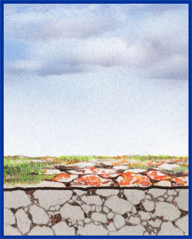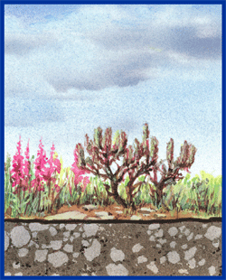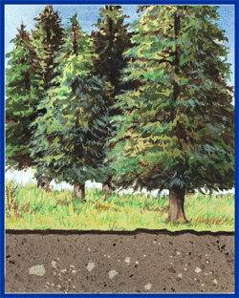
  - Secondary Succession –
    - When a disturbance damages a community but soil remains, the community gets reestablished from seeds and roots left behind. Grasses grow, then small shrubs, and eventually trees.
      - 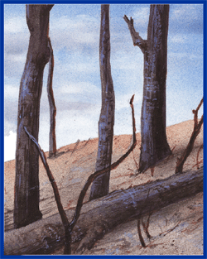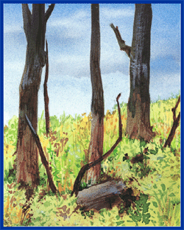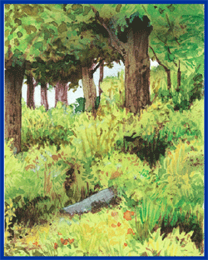
  - Limiting Factor –
    - A factor or condition that prevents the continuing growth of a population in an ecosystem.
  - Carrying Capacity –
    - The maximum size that a population can reach in an ecosystem.
  - Succession –
    - A natural process that involves a gradual change in the plant and animal communities that live in an area.
  - Pioneer Species –
    - The first species to move into a lifeless environment; plants like mosses are typical pioneer species on land.

