Name: _______________________________ Date: ____________________ Core: ________

Pre-Assessment: Cells Unit

Directions – Answer each question in the final answer column. When you are finished answering, place a checkmark (√) in the box that represents your confidence level (did you know the answer or was it a guess).
Final Answers:
Problem Number | Answer | I know the answer! | Guessed on it!
1
2
3
4
5
6
7
8
9
10
11
12
13
14
15
16

Multiple Choice – Select the BEST answer from the choices given.

1. Place the following structures in order from least complex to most complex:
Organs, Cells, Organisms, Tissues, Organ Systems
- Organisms, Organ Systems, Organs, Tissues, Cells
- Cells, Organs, Tissues, Organisms, Organ Systems
- Cells, Tissues, Organs, Organ Systems, Organisms
- Organs, Cells, Tissues, Organ Systems, Organisms

2. According to the cell theory that describes the make-up of all living things, which 2 statements are true? (Pick 2 answers!)
a. cells are only found in plants and animals
b. cells only come from cells that already exist
c. you need a microscope to see any kind of cell
d. all living things are made up of one or more cells

3. Which of the following is something that all types of cells have in common?
a. make their own food
b. have the same shape
c. have cell membranes
d. have cell walls

Matching – Match the following descriptions with the part of the cell it describes.

4. nucleus

5. chloroplast

6. Golgi body

7. mitochondria

8. cytoplasm

9. chromosomes (DNA)

- Packages proteins before they are shipped to other parts of the cell
- Material in cell that holds organelles in place
- Directs all of the cell’s activities
- Organelle that helps convert the Sun’s energy into food
- Located inside the nucleus and codes for traits and behaviors of the cell
- Breaks down glucose to release energy for the cell

Multiple Choice - Select the BEST answer from the choices given.

10. Which of the following is true about bacteria and viruses?
a. they both can reproduce on their own
b. only bacteria have DNA
c. viruses are larger in size than bacteria
d. viruses depend on their host cell for most cell functions

11. Bacteria such as E. coli are one-celled organisms without a nucleus. For these reasons, E. coli is considered which type of organism?
a. eukaryotic
b. fungi
c. animal
d. prokaryotic

12. Complete the analogy: United States is to a cell as President Obama is to….
a. vacuoles
b. cell wall
c. mitochondria
d. chromosomes (DNA)

13. Homeostasis is the process that allows an organism to maintain a steady, regular internal environment. Which of the following process helps the human body maintain the correct amount of oxygen in the blood?
a. bleeding
b. urination
c. eating
d. breathing

Matching – Match each picture with the type of structure used for motion.

_____ 14. flagella _____ 15. cilia _____ 16. pseudopod
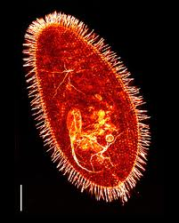
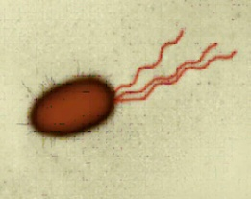
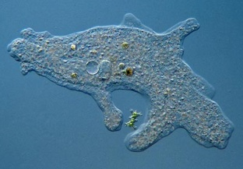
a. b. c.

